1. Project Title: MedVault: Appointment Booking & Medical Records Management System
2. Project Statement and Outcomes:
MedVault is a web-based Personal Electronic Health Record (EHR) System that enables patients to securely store, manage, and exchange their medical records with healthcare professionals. The system empowers patients by allowing them to track their medical history, receive health reminders, and communicate efficiently with doctors or hospitals.
The outcome will be a fully functional web application that streamlines medical record management, ensuring patients have easy access to their health data while maintaining security and privacy. Healthcare professionals will benefit from quick access to patients' medical histories, improving diagnosis and treatment decisions. The system will undergo thorough testing to ensure reliability, with detailed documentation supporting future improvements.
3. Modules to be Implemented:
- Database Design & User Management Module
- Appointment Booking & Consultation Module
- Medical Records Storage & Notifications Module
- Bug Fixing, Review & Documentation
4. Week-wise Module Implementation and High-Level Requirements:
Week 1-2: Database Design & User Management Module
- Design the database schema to manage users' personal and medical data.
- Implement user registration, login, and authentication for both patients and healthcare professionals.
- Create patient profiles where they can securely store and manage their medical records.
- Create professional profiles where doctors and hospitals can access patient records with permission.
Week 3-4: Appointment Booking & Consultation Module
- Implement an appointment booking system where patients can schedule consultations with doctors.
- Allow healthcare professionals to manage their schedules and approve/reject appointment requests.
- Allow patients to leave feedback on consultations, ensuring service improvement.

Week 5-6: Medical Records Storage & Notifications Module
- Enable patients to upload and organize medical records, including prescriptions, test reports, and diagnoses.
- Implement a document categorization system for easy access to medical records.
- Allow healthcare professionals to access medical records upon patient approval.
- Allow patients to update or delete records while maintaining an audit trail.
- Enable notifications and reminders for upcoming appointments, prescription refills, and health checkups.
Week 7-8: Testing, Review, and Documentation
- Conduct a thorough review of the entire system, including functionality, security, and user interface.
- Address any identified bugs or issues and perform necessary fixes.
- Prepare comprehensive documentation covering system architecture, user guides, and technical specifications.

.

5. Flow chart:
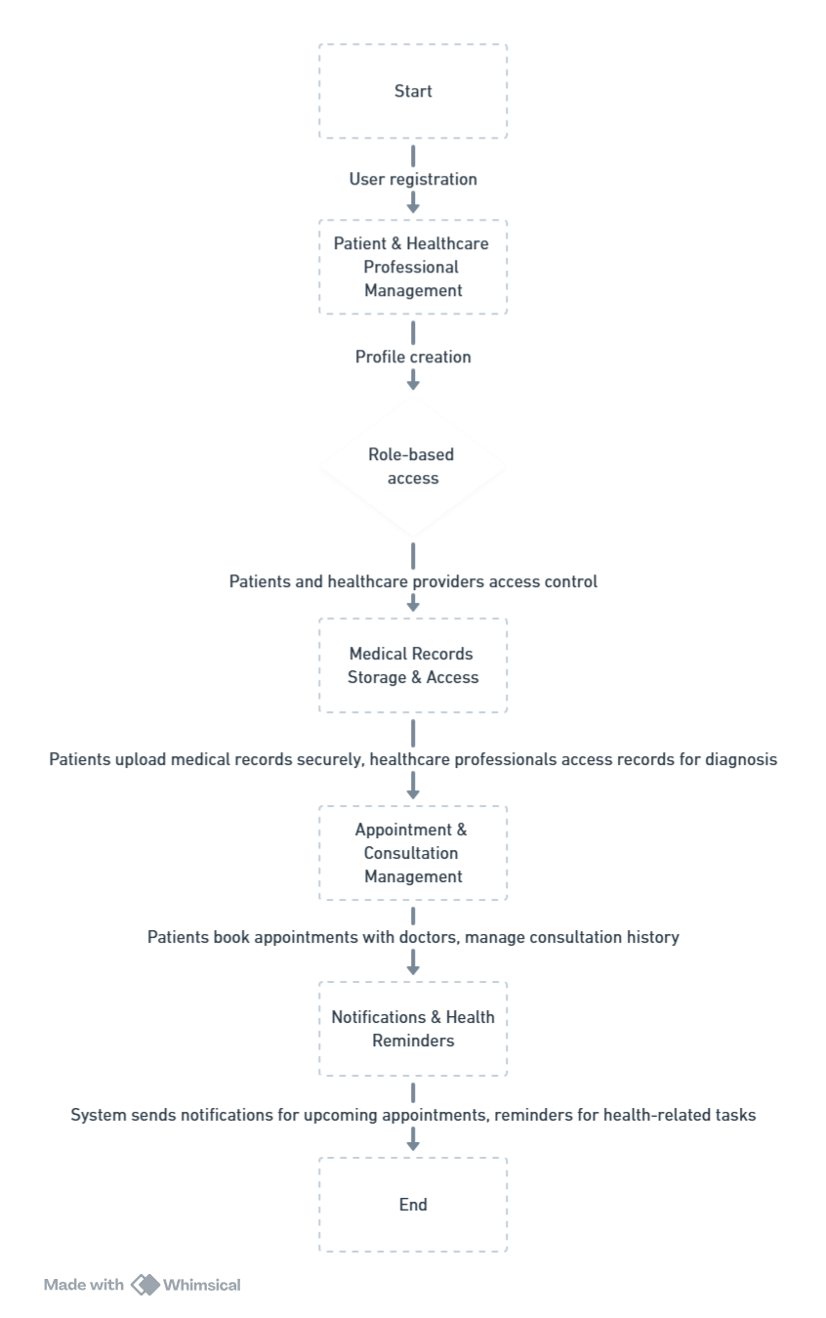
6. Sample Dashboard:

